Hands On Assessment (04 Oct 2023)

Aditya Abhinav (Batch 4)

Data Preparation:

Workspace Created

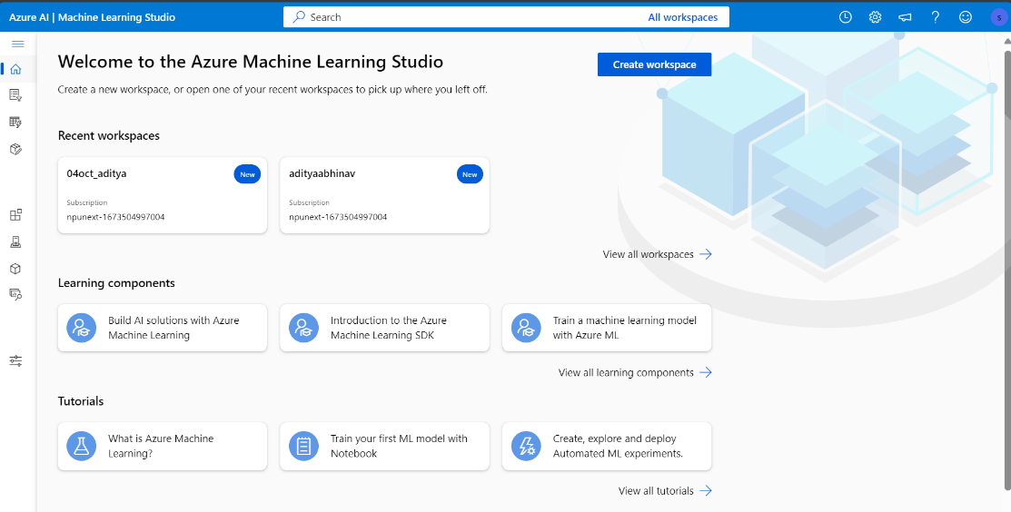

Uploading Data on blob stroage

Taking data from blob storage into ml studio

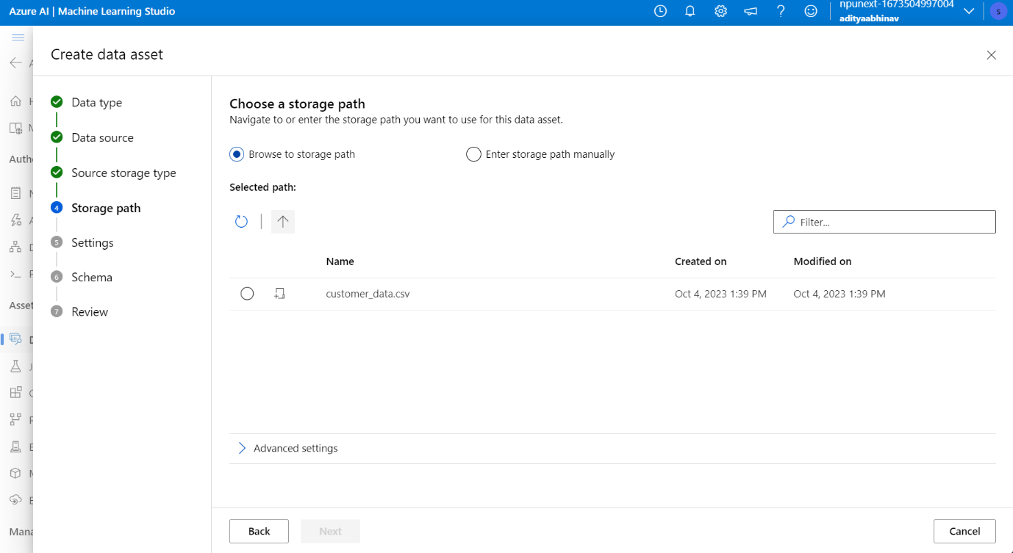

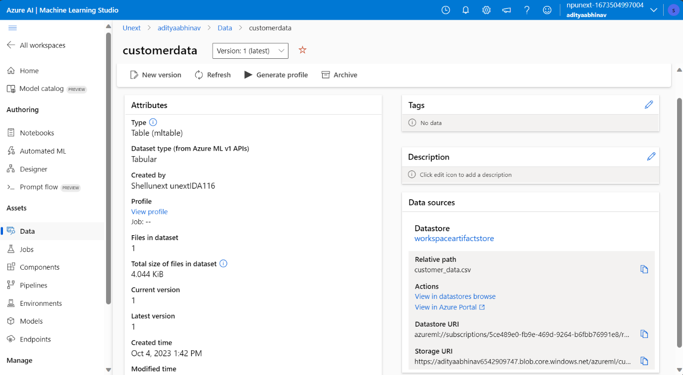

Creating Compute

Selecting feature/columns

Cleaning missing data

Handling Outliers

Normalizing data

Splitting Data

Model Selection

Hyperparameter tuning

Flow

Job Submitted

Job Running

Score

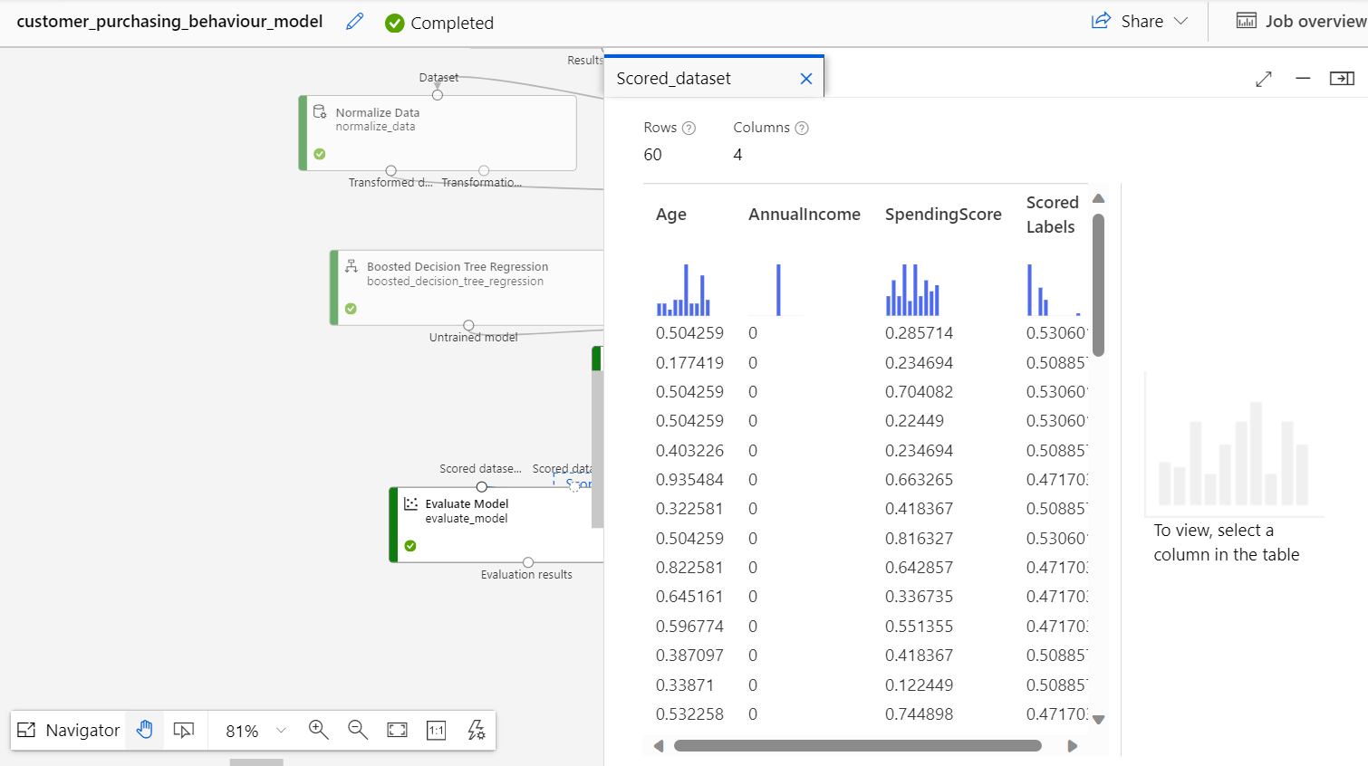

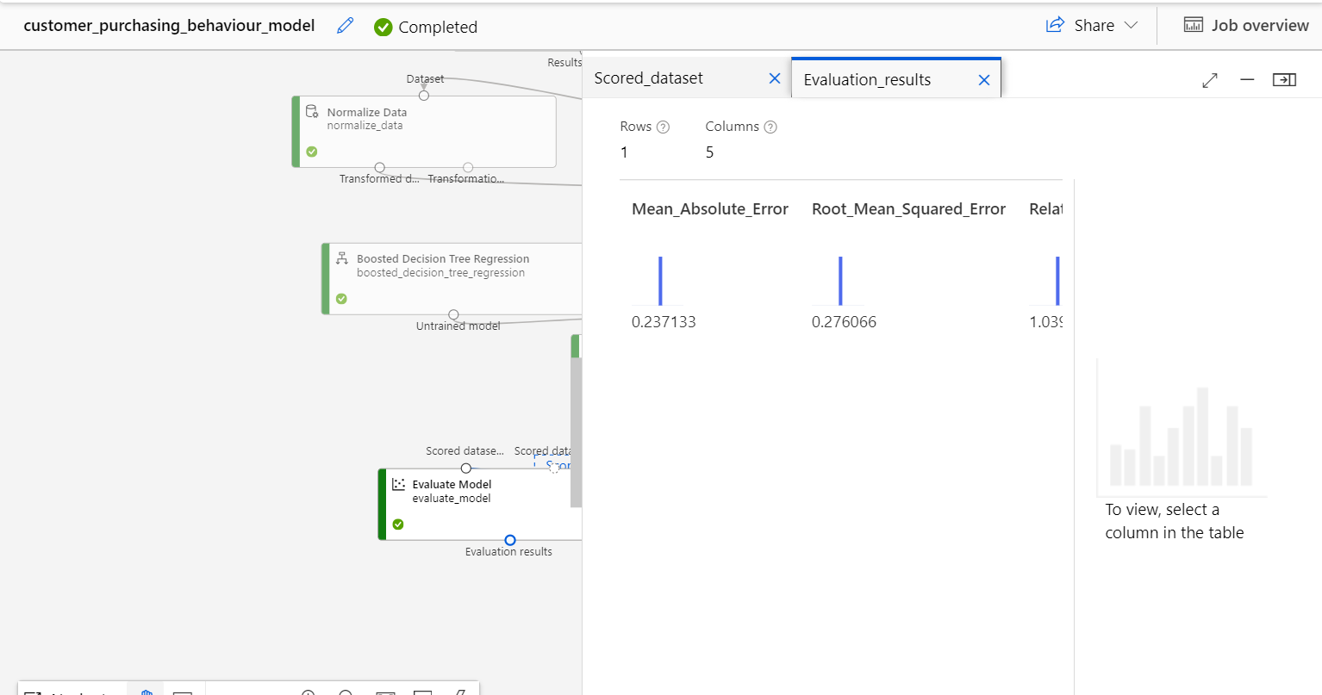

1. Data collection: Collect the data that we shall use to train the model.
2. Data cleaning: Checking for any missing, duplicate or inconsistent data and clean it. We can use various methods such as filling in missing values, removing noisy data and outliers, or resolving conflicts.
3. Data transformation: Normalizing data to reduce dimensions and noise. You can use various methods such as scaling, encoding, or feature engineering to transform your data into a suitable format for your model.
4. Data reduction: Sample data records or attributes for easier data handling. You can use various methods such as filtering, aggregation, or dimensionality reduction to reduce the size and complexity of your dat